***Jetzen***

A Trip Planning App

**Features**

- AI-powered trip planning for seamless travel experiences.

- Real-time adjustments for obstacles during the journey with user's choice to continue or modify plans.

- Budget-friendly trip plans covering everything from hotels to restaurants tailored to your budget.

- Personalized trip plans based on factors like solo travel, family trips, and age considerations.

- Convenient stay options that can be changed directly within the app.

- Recommendations for hotels and restaurants with satisfactory ratings, ensuring a worry-free journey.

(if loading animation not appear or any glitch occurs either reload the page or click on restart option)

(recommended to enable desktop site and click on full-screen mode in top navbar)

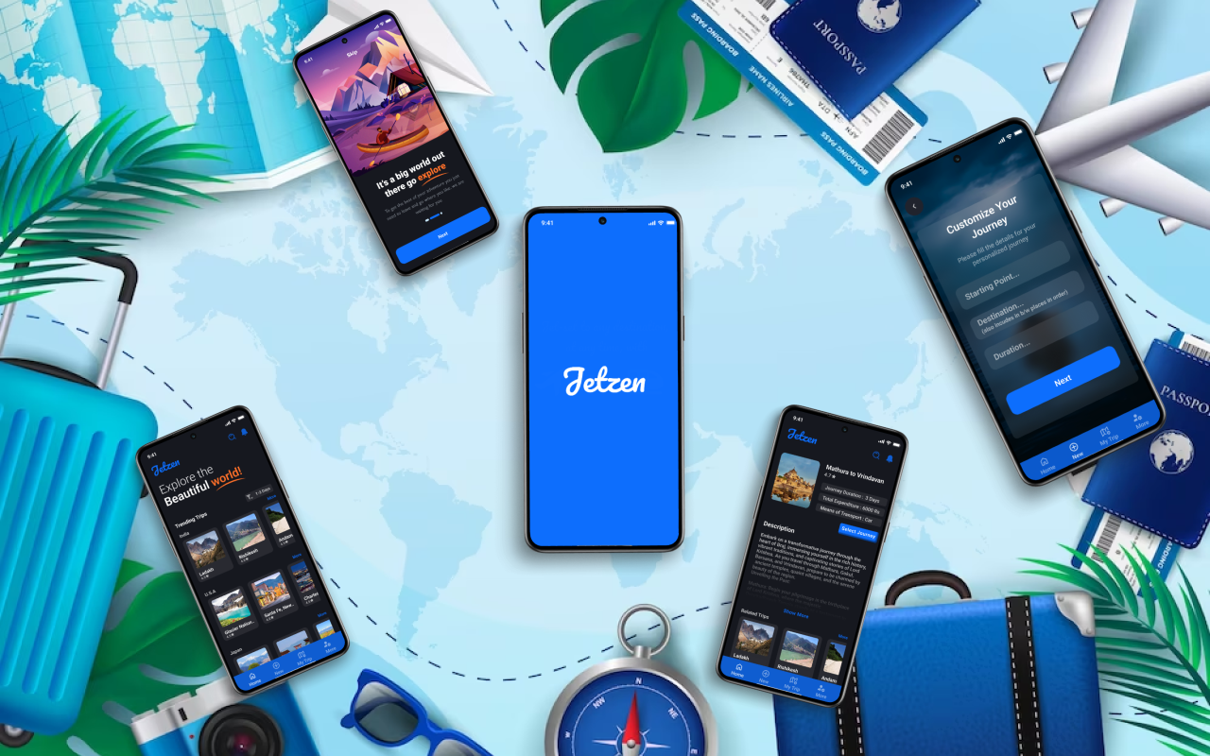Mockup – Android

Link:

<https://www.figma.com/proto/KeJOpkpxQQq5vX8BnPi4Rm/travel-app?page-id=0%3A1&type=design&node-id=1-786&viewport=398%2C316%2C0.07&t=INqw6gzUF8IsN2fz-1&scaling=scale-down&starting-point-node-id=1%3A3091&mode=design>